**Group 88 Work Minutes**

**Team Formation and Initial Setup**

Our group was formed on February 24th, 2025, and officially registered on the QMPLUS platform the following day, February 25th, 2025. The team consists of six members: Xinghan Li, Jiachen Hou, Simeng Lyu,Chang Liu, Junfeng Wang, and Jingyi Liang, with Xinghan Li serving as the team leader.

**Pre-Development Learning Phase**

From February 26th to March 3rd, 2025, the team focused on pre-development learning initiatives.

These included:

1. Gaining a thorough understanding of the group project's requirements and objectives

2. Reviewing Agile development methodologies to align our working practices with industry standards

3. Setting up the project's GitHub workspace to facilitate collaborative coding and version control

**First Weekly Meeting (March 3rd, 2025)**

The first weekly meeting was held on March 3rd, 2025, during which the following key actions and decisions were made:

**Task Allocation and Development Requirements**

1. The team leader clarified the overall project tasks and the requirements for the first development phase
2. The immediate focus was set on completing the product backlog and prototype documentation
3. This week's specific development task was defined as writing user stories for the product backlog

**User Story Writing Guidelines**

1. Each team member was assigned to conduct market research and complete at least three high-quality user stories
2. The user stories were required to not only cover the essential functions specified in the project requirements but also explore extended functionalities to enhance product value

**Training and Tool Selection**

1. The team leader conducted a training session to refresh everyone's memory on user story writing formats and criteria
2. Trello was selected as the platform for writing the backlog, and Fliplet was chosen for creating the prototype
3. The team leader provided guidance on how to effectively use Trello for our backlog management

**Meeting Atmosphere and Team Building**

1. The meeting had a lively and collaborative atmosphere with active participation and consensus-building among all members
2. To strengthen team cohesion and interpersonal relationships, a series of ice-breaking games were organized after the meeting

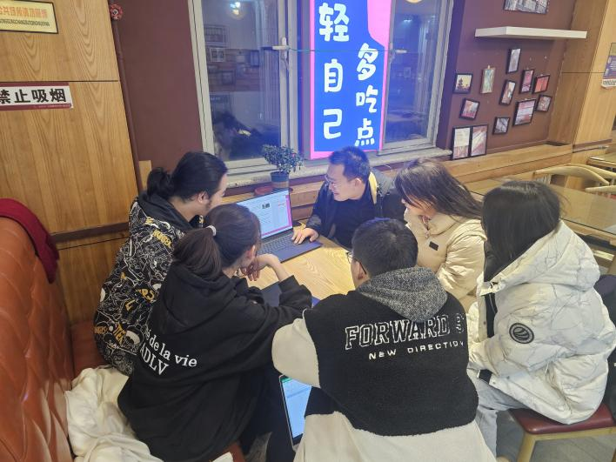

Fig.1|Scene of the first weekly meeting of the group 88

**Second Weekly Meeting (March 10th, 2025)**

The second weekly meeting was conducted on March 10th, 2025. Key outcomes included:

**User Story Consolidation and Prioritization**

1. Team members systematically organized user stories collected through multiple market research methods (including surveys, expert consultations, and analysis of existing similar products)
2. The group unanimously confirmed comprehensive market demand coverage through current user story collection
3. Established standardized prioritization criteria and story sizing metrics through collaborative discussion for subsequent development planning

**Prototype Development Preparation**

1. The team leader conducted a comprehensive demonstration of Filplet prototype design platform operations
2. Defined clear development objectives:

①Complete integration and refinement of existing user stories

②Initiate prototype development organized by epics

③Deliver medium-fidelity prototype designs before next meeting

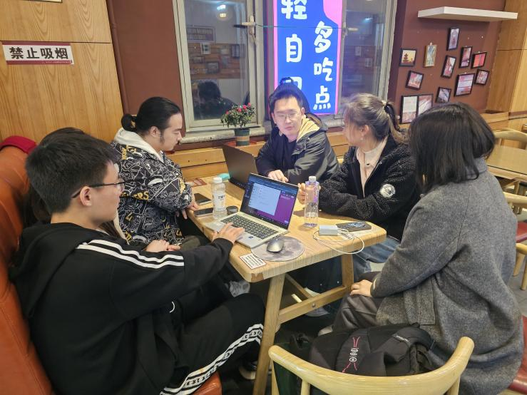

Fig.2|Scene of the second weekly meeting of the group 88

**Stand-up Meetings (March 13th & 16th, 2025)**

The team leader conducted two progress reviews with members on March 13th and 16th, 2025:

1.Verified prototype development alignment with project timeline

2.Facilitated design concept synchronization across team members

3.Addressed interface design challenges through collaborative problem-solving

**Third Weekly Meeting (March 17th, 2025)**

The third weekly meeting occurred on March 17th, 2025, featuring:

**Prototype Review and Iteration Planning**

1. Conducted individual prototype demonstrations with group feedback sessions
2. Identified 6 key improvement areas for interface optimization
3. Established updated requirements:

①Complete acceptance criteria documentation for all user stories

②Schedule prototype iteration before next meeting

③Finalize product branding elements (logo and name) based on core features

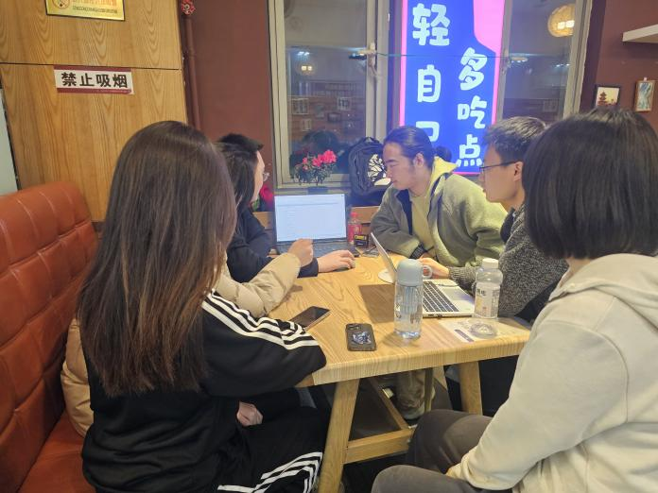

Fig.3|Scene of the third weekly meeting

**Mentor Review Session (March 18th, 2025)**

Selected team members participated in a design critique with course lecturer Muhammad Salman Haleem on March 18th, 2025:

1.Received positive evaluation of current prototype development progress

2.Incorporated several professional recommendations for UX improvements

**First Project Retrospective Meeting (March 20th, 2025)**

The inaugural project retrospective meeting commenced on March 20st, 2025, marking a significant milestone in our development process. The session encompassed two main agenda items:

**Project Review & Experience Sharing**

Team members systematically conducted knowledge sharing regarding challenges encountered during the month-long backlog refinement and prototype design phase, accompanied by corresponding solutions. Key insights included:

①Implementation of Agile methodology for backlog iteration management

②Resolution of technical bottlenecks through collaborative problem-solving sessions

③Optimization of user story mapping through cross-functional validation

**Prototype Finalization & Phase Reporting Planning**

1. The team collectively executed final adjustments to the prototype system, achieving consensus on:

①Core feature validation through user flow simulation

②Interface optimization based on usability heuristics

③Technical documentation standardization

1. Established formalized guidelines for the Phase 1 Checkpoint Presentation, specifying:

①Structured reporting framework comprising project progress, risk analysis, and next-phase roadmap

②Multimedia presentation standards incorporating interactive prototype demonstration

③Collaborative Q&A preparation protocol for stakeholder review

This retrospective meeting effectively consolidated project deliverables while enhancing team alignment for subsequent development phases.

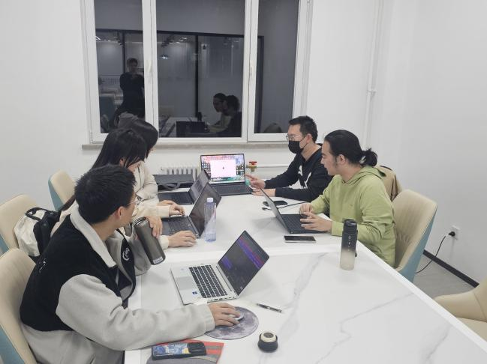

Fig.4|Scene of the first project retrospective meeting

**Fourth Weekly Meeting (March 30th, 2025)**

The fourth weekly meeting was held on March 30th, 2025. Key outcomes included:

1.Code Integration and Task Formalization

2.Consolidated preliminary code achievements from previous development phases

3.Officially allocated implementation tasks to team members based on individual technical strengths.

**Defined core development focus:**

①Team members to independently write component layout code for their assigned UI interfaces.

②Establish code modularity standards for seamless future integration.

**Fifth Weekly Meeting (April 7th, 2025)**

The fifth weekly meeting convened on April 7th, 2025. Major developments included:

1.Development Progress Review and Enhancement Planning.

2.Conducted comprehensive analysis of last week's coding outputs and interface implementation status.

**Formulated next-stage implementation requirements:**

①Members to complete specific interface logic for their assigned modules

②Develop enhanced functionalities such as page navigation and file read/write operations.

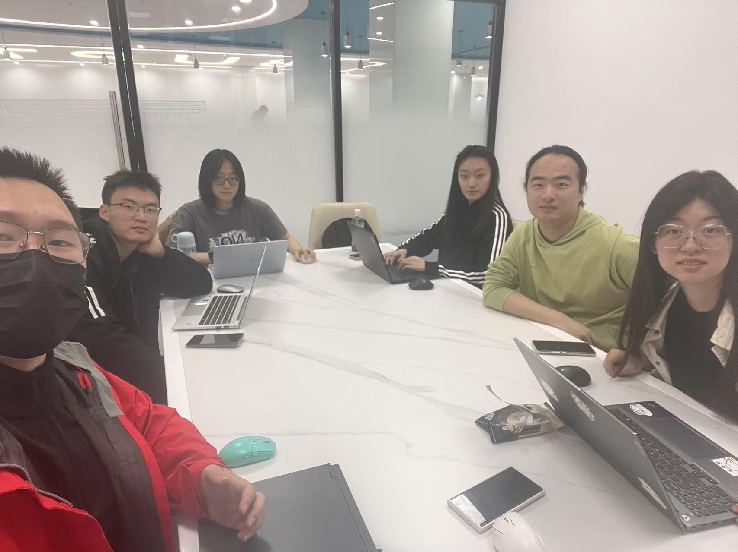

Fig.5|Scene of the fifth weekly meeting

**Sixth Weekly Meeting (April 14th, 2025)**

The sixth weekly meeting occurred on April 14th, 2025. Critical preparations included:

1.Code Consolidation and Pre-Review Optimization

2.Systematically integrated all members' code contributions from previous development cycles.

**Defined final implementation objectives:**

①Complete advanced feature implementation through collaborative coding.

②Execute comprehensive debugging and troubleshooting procedures.

**Finalized preparation framework for Interim 2 Checkpoint Presentation:**

①Conduct dry-run simulations of system functionality

②Establish rapid response protocol for potential Q&A scenarios